

**SCHOOL OF** **COMPUTER SCIENCE AND ENGINEERING**

A Mini Project Report

on

AI-BASED GRIEVANCE LODGING AND TRACKING SYSTEM

Submitted in fulfillment of the requirements for the award of the Degree of

**Bachelor of Technology**

**In**

**Artificial Intelligence and Data Science**

Submitted by

Chandana K P (R22EH015)

Keerthana R (R22EH031)

Priyanka S (R22EH047)

Under the guidance of

Dr Mayuri Kundu

Assistant Professor  
School of Computer Science and Engineering

2024-2025

Rukmini Knowledge Park, Kattigenahalli, Yelahanka, Bengaluru-560064

www.reva.edu.in

**DECLARATION**

We, Ms. **Chandana K P, Keerthana R, Priyanka S**, students of Bachelor of Technology in Artificial Intelligence and Data Science, School of Computer Science and Engineering REVA University, declare that this entitled **“AI-BASED GRIEVANCE LODGING AND TRACKING SYSTEM”** is the result the of mini project work done by us under the supervision of Dr. Mayuri Kundu , at School of Computer Science and Engineering, REVA University.

We are submitting this Mini Project Report in partial fulfillment of the requirements for the award of the degree of the Bachelor of Technology in Artificial Intelligence and Data Science by the REVA University, Bengaluru during the academic year 2024-25.

We declare that this project report has been tested for plagiarism and has passed the plagiarism test with the similarity score of less than 20% and it satisfies the academic requirements in respect of Project work prescribed for the said Degree.

We further declare that this mini project report or any part of it has not been submitted for award of any other Degree / Diploma of this University or any other University/ Institution.

*Signature of the candidates with dates*



*Certified that this mini project work submitted by the students has been carried out under my guidance and the declaration made by the candidates is true to the best of my knowledge.*

|  |  |
| --- | --- |
| *Signature of Guide* |  |
| *Date: …………….* |  |

|  |  |
| --- | --- |
| *Signature of HoD, AI&DS* | *Signature of Director* |
| *Date: …………….* | *Date: …………….* |
|  | *Official Seal of the School* |

**SCHOOL OF** **COMPUTER SCIENCE AND ENGINEERING.**

**CERTIFICATE**

Certified that the mini project work entitled **AI-BASED GRIEVANCE LODGING AND TRACKING SYSTEM** carried out under my guidance by **Chandana K P, Keerthana R, Priyanka S**, **R22EH015, R22EH031, R22EH047**, are bonafide students at REVA University during the academic year 2024-25, are submitting the mini project report in partial fulfillment for the award of **Bachelor of Technology** in **Artificial Intelligence and Data Science** during the academic year **2024-25.** The project report has been tested for plagiarism and passed the plagiarism test with a similarity score less than 20%. The project report has been approved as it satisfies the academic requirements in respect of Project work prescribed for the said Degree.

|  |  |
| --- | --- |
| **Signature with date** |  |
|  |  |
| **Guide name** |  |
| **Guide** |  |

|  |  |
| --- | --- |
| **Signature with date** | **Signature with date** |
|  |  |
| **Name of the HoD** | **Name of the Director** |
| **HoD, AI&DS** | **Director** |

**External Examiners**

**Name of the Examiner with** **affiliation** **Signature with Date**

1.

2.

**ACKNOWLEDGEMENT**

Any given task achieved is never the result of the efforts of a single individual. There are always a bunch of people who play an instrumental role leading a task to its completion. Our joy at having successfully finished our mini project work would be incomplete without thanking everyone who helped us out along the way. We would like to express our sense of gratitude to our REVA University for providing us the means of attaining our most cherished goal.

We would like to thank our Hon’ble Chancellor, Dr. P. Shyama Raju and Hon’ble Vice-Chancellor, Dr. Sanjay R Chitnis for their immense support towards students to showcase innovative ideas.

We cannot express enough thanks to our respected Director, Dr. Ashwinkumar U M for providing us with a highly conducive environment and encouraging the growth and creativity of each and every student. We acknowledge the unwavering support of the Head of Department, Prof. Kiran M and express our sincere gratitude. We acknowledge the support and we would also like to offer our sincere gratitude to our Project Coordinators for the numerous learning opportunities that have been provided.

We would like to take this opportunity to express our gratitude to our Mini Project Guide, Guide Name, for continuously supporting and guiding us in our every endeavor as well as for taking a keen and active interest in the progress of every phase of our Mini Project. Thank you for providing us with the necessary inputs and suggestions for advancing with our Project work. We deeply appreciate the wise guidance that sir has provided.

Finally, we would like to extend our sincere thanks to all the faculty members and staff from the School of Computer Science and Engineering.

List of Group Members

**Table Contents**

|  |  |
| --- | --- |
| List of tables with titles and page references | <Page No> |
| List of illustrations / Screen Shots if any, with titles and page references | <Page No> |
| List of Symbols, Abbreviation of Nomenclature | <Page No> |
| Abstract | <Page No> |
| 1. Introduction | <Page No> |
| 1. Literature Survey | <Page No> |
| 1. Positioning | <Page No> |
| * 1. Problem statement | <Page No> |
| * 1. Product position statement | <Page No> |
| 1. Project overview | <Page No> |
| * 1. Objectives | <Page No> |
| * 1. Goals | <Page No> |
| 1. Project Scope | <Page No> |
| 1. Methodology | <Page No> |
| 1. Modules identified | <Page No> |
| 1. Project Implementation | <Page No> |
| * 1. Architectural Design, Circuit Design (Hardware Project) and Mechanical and Control Unit Design (Robotics or automation projects) | <Page No> |
| * 1. Class Diagram | <Page No> |
| * 1. Entity Relationship Model | <Page No> |
| * 1. Sequence Diagram | <Page No> |
| * 1. Description of Technology Used | <Page No> |
| 1. Findings / Results of Analysis | <Page No> |
| 1. Cost of the Project | <Page No> |
| 1. Conclusions | <Page No> |
| 1. Project Limitations and Future Enhancements | <Page No> |
| References | <Page No> |
| Appendices, if any | <Page No> |
| Publication Details | <Page No> |

***Abstract:***

*The* ***AI-Based Grievance Lodging and Tracking System (GrievanceNavigator)*** *addresses the persistent inefficiencies in conventional grievance redressal mechanisms prevalent in public and private sector institutions. Traditional grievance handling systems often suffer from delays, misclassification of complaints, lack of prioritization, and absence of real-time tracking — resulting in citizen dissatisfaction and operational bottlenecks. This project proposes an innovative, AI-driven grievance management system that leverages the capabilities of* ***Artificial Intelligence (AI)*** *and* ***Natural Language Processing (NLP)*** *to automate the lodging, classification, prioritization, and resolution tracking of complaints across multiple departments.*

*The primary goal of this project is to simplify and accelerate the grievance redressal process by deploying AI-powered complaint categorization, machine learning-based priority assignment, and real-time tracking features through a user-friendly digital interface. Citizens can submit grievances via a* ***web portal or mobile-friendly interface****, where the system’s AI module classifies complaints into relevant categories — such as road safety, electricity, water supply, and public sanitation — while simultaneously assigning priority levels based on severity analysis. The integration of* ***fraud detection mechanisms*** *helps identify duplicate or irrelevant complaints, streamlining administrative workload and ensuring genuine grievances receive timely attention.*

*A key feature of this system is its* ***real-time status tracking dashboard and automated notification service****, which provides users with complaint updates through email and SMS alerts. Additionally, the system employs* ***Role-Based Access Control (RBAC)*** *to maintain data security by ensuring that only authorized officials can access or resolve specific complaints. The AI-driven analytics dashboard equips administrators with actionable insights into recurring issues and complaint trends, enabling data-driven governance and strategic decision-making.*

*Designed on a scalable cloud-based infrastructure, the platform is equipped for multi-departmental integration and can adapt to diverse civic environments, including urban and rural regions. Future enhancements, such as* ***multilingual support, voice-enabled complaint registration, mobile application development, and advanced AI models like BERT or RoBERTa****, are proposed to further improve inclusivity and operational efficiency.*

* **Introduction:**

### **Background and Context**

In modern public administration and institutional governance, effective grievance redressal systems are vital for maintaining public trust, operational efficiency, and responsive service delivery. Every year, government bodies, municipal corporations, and private organizations receive thousands of complaints ranging from civic issues like potholes, garbage collection delays, and electricity disruptions to service-related grievances in banks, telecom, and healthcare. Traditional grievance management practices rely heavily on manual processing, physical registers, or web portals lacking automation. These outdated systems lead to delayed responses, unresolved complaints, absence of transparent tracking mechanisms, and frustration among citizens.

Moreover, with the rapid increase in urban populations and public infrastructure demands, the volume of grievances has also grown. Departments often struggle to sort, categorize, and prioritize these complaints efficiently. Due to limited resources and conventional complaint classification practices, high-priority grievances such as safety hazards, medical emergencies, or large-scale utility failures often get delayed or overlooked, leading to potential risks and public dissatisfaction.

### **Scenario and Motivation for the Project**

Recognizing these critical issues and their impact on public trust and governance quality, there is an urgent need for a **technology-driven, AI-powered grievance management system.** Artificial Intelligence (AI) and Natural Language Processing (NLP) technologies have proven capabilities in automating text classification, sentiment analysis, and decision prioritization tasks in various domains. Their integration into grievance management frameworks can revolutionize complaint handling by automating complaint categorization, predicting urgency levels, eliminating duplicate grievances, and offering real-time status updates to both citizens and administrators.

Our motivation for choosing this project stems from the growing emphasis on **Digital India initiatives, e-Governance, and smart city solutions** where intelligent systems play a significant role in improving citizen services. By developing an AI-based grievance redressal system, we aim to demonstrate how emerging technologies can be applied to socially relevant issues, enhancing both public satisfaction and operational efficiency. Additionally, this project allows us to explore and implement practical AI techniques like text classification, priority-based filtering, fraud detection, and AI-powered dashboards within a real-world application.

With scalable, cloud-based infrastructure and modular design, the system holds the potential for expansion across multiple government departments, educational institutions, and customer service organizations. This makes it not only a valuable academic exercise but also a practical, impactful solution addressing a persistent civic problem.

* **Literature Survey:**

### **Overview of Similar Existing Solutions / Research**

Grievance redressal systems have been a critical part of public administration and customer service frameworks globally. Over the years, various solutions have been proposed and implemented, ranging from traditional manual systems to basic web portals and AI-integrated platforms. However, most existing systems suffer from inefficiencies like delayed response times, lack of real-time tracking, misclassification of complaints, and difficulty in handling large volumes of grievances.

**IBM Watson’s AI-Powered Complaint Management Solution** is one of the leading examples of AI-driven grievance redressal systems. It uses Natural Language Processing (NLP) to understand the context and intent of complaints and automatically categorizes them into predefined issue areas. However, it is highly enterprise-oriented, expensive, and lacks region-specific adaptability, especially in multilingual and localized public grievance environments.

Similarly, several **AI-based Citizen Service Platforms** have emerged globally and in India, focusing on automating the routing and prioritization of citizen complaints. Most of these systems provide automated classification and status updates but lack advanced fraud detection features and deep AI-based priority assessment models.

The **Press Information Bureau (PIB)** highlights in its 2021 report how AI technologies are being integrated into grievance management systems under initiatives like **CPGRAMS (Centralized Public Grievance Redress and Monitoring System)** in India. While significant progress has been made in digitizing complaint registrations, the system is still largely dependent on human intervention for classification, prioritization, and status monitoring.

Commercial service platforms like **Sprinklr** and **LeewayHertz AI Complaint Management Systems** offer AI-enhanced complaint management capabilities for enterprises, providing real-time notifications, ticketing, and automated responses. However, their models are primarily customer-service focused and not tailored for civic administration challenges like cross-department routing, priority-based escalation, or multilingual complaint handling in a public governance context.

A research paper published in the **Foundry Journal (2024)** proposed an AI-powered complaint management system for educational institutions using Django and a rule-based classification system. While effective in its scope, the system lacked AI-based prioritization, fraud detection mechanisms, and real-time tracking dashboards, limiting its scalability for public sector use.

### **Identified Gaps and Justification for the Proposed Solution**

From the comparative analysis and review of existing research and systems, several gaps in the current grievance redressal solutions were identified:

* **Lack of AI-Based Prioritization:** Most systems either rely on manual triage or basic rule-based classification, failing to assess complaint urgency based on sentiment or context.
* **Limited Fraud Detection Mechanisms:** Duplicate or fake complaints remain a common issue, wasting administrative resources.
* **Absence of Multilingual Support:** Most AI solutions focus on English, while India and many countries require multi-language grievance systems.
* **High Costs & Enterprise Focus:** Solutions like IBM Watson are enterprise-grade and financially unviable for municipal or public sector bodies in developing nations.
* **Inadequate Real-Time Tracking:** Many systems lack a dynamic status dashboard and automated notification features for users.

**Justification for the Proposed Solution:**  
This project addresses these gaps by integrating **AI and NLP-based complaint classification, priority-based escalation using sentiment and keyword analysis, fraud detection algorithms, and a real-time tracking dashboard**. It also proposes future enhancements like **multi-language support** and **mobile app integration**, making it a **scalable, affordable, and citizen-friendly grievance redressal solution** suitable for public governance, educational institutions, and customer-facing organizations.

* **Positioning**

1. **Problem statement:**

In public administration, educational institutions, and service-based organizations, the grievance redressal process remains a critical yet often neglected area in terms of operational efficiency and citizen satisfaction. Traditional grievance handling systems are largely manual or rely on basic digital portals that lack automation, efficient categorization, priority-based management, and real-time tracking features. This results in delayed responses, unaddressed complaints, misclassification, and citizen dissatisfaction.

Moreover, with the growing urban population, increasing service demands, and the rising number of public complaints, existing systems struggle to manage and resolve grievances within acceptable timelines. High-priority issues such as health hazards, electricity failures, and public safety concerns frequently get buried under a backlog of minor complaints due to the absence of AI-driven prioritization mechanisms.

Another significant problem is the absence of fraud detection modules, leading to administrative inefficiencies caused by duplicate or irrelevant complaints. Additionally, existing systems often lack real-time tracking dashboards and automated status notifications, forcing citizens to repeatedly follow up on their complaints through manual channels.

This project proposes to address these limitations by developing an AI-Based Grievance Lodging and Tracking System equipped with AI and Natural Language Processing (NLP) models for automatic complaint classification, priority assignment, fraud detection, and real-time grievance tracking. The system aims to improve grievance management efficiency, transparency, and user satisfaction while providing administrators with actionable data insights through AI-powered analytics dashboards.

1. **Product position statement:**

For public administrative bodies, educational institutions, and customer service organizations who need an efficient, transparent, and scalable grievance redressal system,  
our product is an AI-Based Grievance Lodging and Tracking System  
that automatically classifies, prioritizes, and tracks grievances using AI and NLP models, providing real-time updates and actionable analytics.  
Unlike traditional grievance systems or expensive enterprise platforms like IBM Watson,  
our system is cost-effective, scalable, citizen-friendly, and adaptable to regional, multilingual, and institutional contexts, designed to improve operational efficiency and public satisfaction.

* **Project overview:**

The AI-Based Grievance Lodging and Tracking System is a web-based platform designed to automate and improve the efficiency of complaint management in public administration and institutional governance. The system aims to replace traditional, manually operated grievance redressal mechanisms, which are often slow, opaque, and error-prone, with a smart, AI-powered solution that ensures faster response times, accurate complaint classification, priority-based handling, and real-time status updates.

This project leverages Artificial Intelligence (AI) and Natural Language Processing (NLP) to automatically categorize grievances into relevant departments and assign priority levels based on the severity and context of the complaint. Citizens can easily lodge complaints through a user-friendly online form, while administrators can track, manage, and resolve complaints efficiently using a dynamic dashboard equipped with AI-powered analytics.

The system is designed to be scalable and adaptable, capable of handling complaints across multiple departments like water supply, electricity, road maintenance, sanitation, healthcare, and public safety. It also includes features such as duplicate complaint detection, sentiment analysis for urgency detection, automated SMS/email notifications, and Role-Based Access Control (RBAC) to secure sensitive information and allocate responsibilities appropriately.

Developed using lightweight and widely used frameworks such as Flask or Django for backend services and React.js or Vue.js for the frontend interface, the system integrates a Firebase or SQLite database to manage complaint records securely. Real-time notifications are facilitated through services like Twilio or SendGrid, and cloud deployment ensures accessibility and scalability.

This AI-based solution is particularly relevant in the context of India’s Digital India initiative and the increasing demand for smart governance solutions in urban and rural areas. By addressing key limitations of existing systems — such as delayed response, lack of prioritization, absence of real-time tracking, and administrative inefficiencies — this project has the potential to improve public service delivery and citizen satisfaction significantly.

The system’s modular, cloud-friendly architecture also makes it suitable for educational institutions, customer service organizations, and smart city initiatives that require an efficient and transparent grievance redressal mechanism. Future extensions of the system include multilingual complaint submission, mobile application development, chatbot integration, and IoT-based infrastructure issue reporting, ensuring its relevance and scalability in diverse civic and institutional environments.

1. **Objectives:**

The primary objective of this project is to design and develop an **AI-powered grievance lodging and tracking system** capable of automating the processes of **complaint registration, categorization, prioritization, and real-time tracking** across multiple departments. This system aims to enhance the efficiency, accuracy, and transparency of grievance redressal mechanisms within public governance, educational institutions, and customer service platforms.

1. **Goals:**

* **To develop a user-friendly web-based platform** that allows citizens to conveniently lodge grievances and track their complaint status in real time.
* **To implement AI and NLP models for automatic classification of complaints** into predefined categories such as electricity, sanitation, public infrastructure, healthcare, etc., minimizing human error and manual workload.
* **To incorporate an AI-driven priority assignment mechanism** based on sentiment analysis and keyword detection, ensuring that urgent or critical issues are identified and addressed promptly.
* **To design and integrate a real-time complaint status tracking module**, allowing both users and administrators to monitor the progress of grievances at various stages from submission to resolution.
* **To enable automated SMS and email notification services** using third-party APIs (like Twilio or SendGrid), keeping complainants updated on their grievance status.
* **To implement a fraud detection system** capable of identifying duplicate, irrelevant, or non-genuine complaints, thereby improving administrative efficiency.
* **To provide an administrator dashboard** equipped with analytics tools to visualize complaint trends, department-wise complaint counts, resolution rates, and recurring issues for decision-making support.
* **To develop a secure system with Role-Based Access Control (RBAC)** ensuring that only authorized personnel can access, manage, and resolve specific complaints.
* **To design the system with scalability in mind,** allowing for future integration of multilingual support, mobile application access, AI chatbots for automated replies, and IoT-based issue reporting modules.
* **To follow an Agile development methodology** for the systematic, incremental, and flexible implementation of system modules, ensuring continuous testing and improvements throughout the project life cycle.
* **Project Scope**

### **General Project Information**

**Project Title:** AI-Based Grievance Lodging and Tracking System  
**Project Type:** Mini Project (Web-Based AI Application)  
StudentTeam: (3 members)  
**Development Methodology:** Agile

### **Problem / Opportunity Statement**

The current grievance redressal mechanisms used in public services, educational institutions, and service-based organizations are largely manual or limited to basic digital systems without intelligent automation. This leads to frequent delays, inaccurate categorization, a lack of priority-based handling, and citizen dissatisfaction due to poor transparency and inefficient complaint resolution.  
The opportunity lies in leveraging **Artificial Intelligence (AI)** and **Natural Language Processing (NLP)** to automate the lodging, classification, prioritization, and real-time tracking of complaints, improving operational efficiency, public trust, and user experience.

### **Business Benefits**

The proposed AI-Based Grievance Lodging and Tracking System offers the following tangible and strategic benefits:

* **Faster Complaint Processing:** Automating classification and prioritization reduces response times.
* **Improved Transparency:** Real-time status tracking and notifications improve citizen trust.
* **Reduced Administrative Overhead:** Automated fraud detection minimizes redundant or fake complaints.
* **Informed Decision Making:** AI-generated analytics dashboards provide actionable insights on service gaps and operational trends.
* **Scalability:** Designed to easily integrate with additional departments, services, and future technologies like multilingual support and mobile applications.
* **Cost-Effective:** Uses open-source and cloud-based tools, ensuring affordability for institutions with limited IT budgets.

### A fully functional **web-based grievance lodging system AI-powered classification and priority assignment module** using NLP **Real-time complaint status tracking system** with dynamic progress indicators **Automated notification system (email/SMS)** for user updates **Fraud detection mechanism** for duplicate or invalid complaints **Role-Based Access Control (RBAC)** for secure access management **Administrator dashboard** with AI-generated analytics and reporting features **Documentation** including system user manual and project report Optional: Proposal plan for future enhancements (multilingual chatbot, mobile app integration)

### **Estimated Project Duration**

|  |  |
| --- | --- |
| **Phase** | **Timeline (Weeks)** |
| Requirement Analysis & Research | 2 |
| AI/NLP Model Development | 2 |
| Backend & Database Development | 2 |
| Frontend Development | 2 |
| System Integration & Testing | 2 |
| Deployment & Final Review | 2 |
| **Total Duration** | **12 weeks (3 months)** |

* **Methodology**

The methodology adopted for this project represents a **combination of logically related practices, processes, and workflows** that govern how the project is planned, designed, developed, tested, and delivered. It provides a structured and systematic approach to efficiently transform project requirements into a working AI-based grievance management solution within the stipulated time and resources.

To ensure flexibility and continuous improvements during the development, this project follows the **Agile Development Methodology**. Agile allows the team to break down the project into iterative sprints, addressing challenges as they arise and continuously refining the system based on regular feedback and testing.

### **Development Approach: Agile Methodology**

* **Iterative and incremental development cycles** (Sprints)
* Regular feedback incorporation after each sprint
* Parallel development of AI model, backend, and frontend modules
* Continuous testing and refinement after every sprint
* Modular deployment ensuring scalability and easy future upgrades

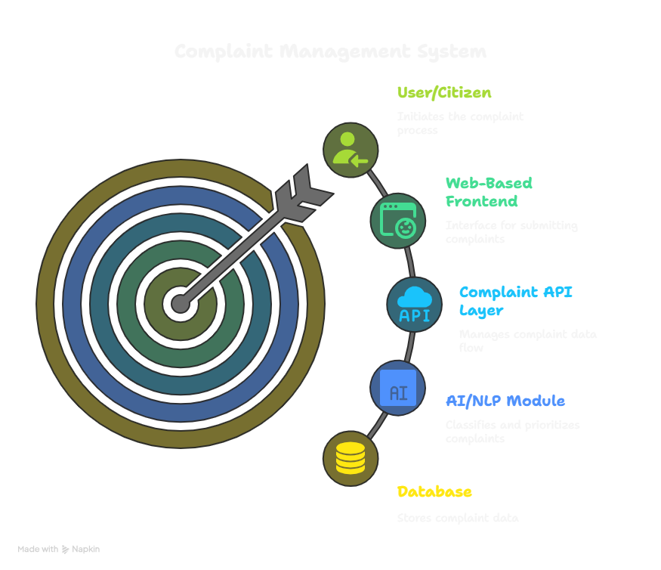

## **Project Development Phases**

|  |  |
| --- | --- |
| **Phase** | **Activity** |
| Requirement Analysis & Literature Survey | Understand existing systems, gather requirements, feasibility study |
| System Design & Planning | Define architecture, design workflows, select tools |
| AI/NLP Model Development | Build AI model for complaint classification and priority assignment |
| Backend & Database Development | Design and develop APIs, integrate database |
| Frontend Development | Create user-friendly web interface |
| System Integration | Connect AI, backend, and frontend modules |
| Testing & Debugging | Unit testing, system testing, bug fixing |
| Final Deployment & Documentation | Deploy project on cloud, prepare report, document the system |

* **Modules identified:**

### **User Complaint Lodging Module**

**Description:**  
Allows users (citizens/customers) to submit their complaints through a web-based form.

**Processes Included:**

* User inputs grievance details (description, category, location, etc.)
* Option to upload images/documents (if applicable)
* Data validation and submission to the backend
* Generates a unique complaint ID

### **AI-Based Complaint Classification & Prioritization Module**

**Description:**  
Automates the categorization of grievances using AI/NLP techniques and assigns priority levels based on complaint content.

**Processes Included:**

* Process complaint text using AI/NLP libraries
* Classify complaint into predefined categories (e.g., Water, Roads, Electricity)
* Analyze sentiment and keywords to determine urgency
* Assign priority level (High, Medium, Low)

### **Database Management Module**

**Description:**  
Responsible for storing, updating, retrieving, and managing complaint data.

**Processes Included:**

* Store complaint details, classification, priority, status updates
* Track complaint progress
* Manage administrator and user data
* Secure data access through Role-Based Access Control (RBAC)

### **Real-Time Grievance Tracking Module**

**Description:**  
Enables users and administrators to monitor the current status and progress of complaints in real-time.

**Processes Included:**

* Track complaints using Complaint ID
* Display status updates (Received, In-Progress, Resolved)
* Notify users about changes in complaint status
* Update complaint records upon resolution

### **Fraud Detection & Duplicate Filtering Module**

**Description:**  
Identifies duplicate or irrelevant complaints to reduce administrative workload.

**Processes Included:**

* Check for duplicate entries by comparing new complaint text with existing records
* Identify fake/invalid complaints based on predefined parameters
* Mark and discard duplicate or fake entries

### **Notification & Alerts Module**

**Description:**  
Handles automated SMS and email notifications to keep users informed about complaint status.

**Processes Included:**

* Send confirmation message upon complaint submission
* Notify status updates (In-Progress, Resolved) via email/SMS
* Integrate with APIs like Twilio and SendGrid for communication services

### **Administrator Management Module**

**Description:**  
Allows authorized officials to view, manage, and resolve complaints through a dashboard.

**Processes Included:**

* View categorized and prioritized complaints
* Update complaint status and resolution details
* Generate performance and analytics reports
* Manage admin login and access control

### **Analytics & Reporting Module**

**Description:**  
Provides administrators with AI-generated analytics to identify trends and service gaps.

**Processes Included:**

* Generate visual reports on department-wise complaints
* Track average resolution time
* Identify frequently reported issues
* Support decision-making through data insights
* **Project Implementation**

### **High-Level System Architecture**

The system is designed in a **modular, layered architecture** comprising the following major components:

* **Frontend Web Application**: Provides the user interface for citizens and administrators to lodge, track, and manage grievances.
* **Backend Application Server**: Manages complaint submissions, processes them using AI/NLP modules, handles database operations, and triggers notifications.
* **AI/NLP Engine**: Analyzes complaint content, classifies them into categories, assigns priority, and detects duplicate or invalid complaints.
* **Database System**: Stores complaints, user records, status updates, admin data, and analytics reports.
* **Notification Service**: Sends automated SMS and email updates via integrated APIs like Twilio/SendGrid.

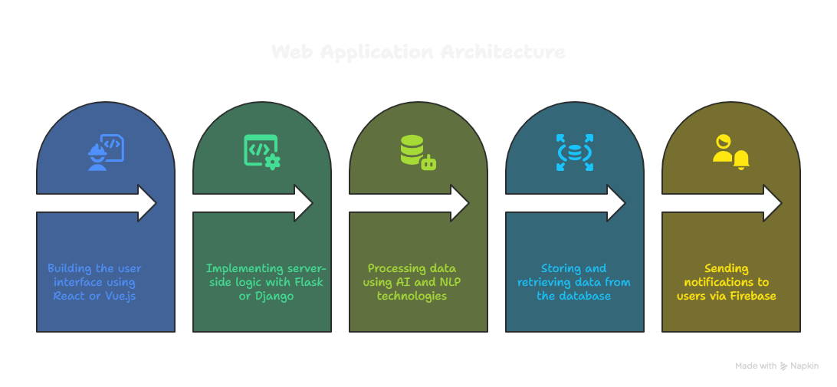

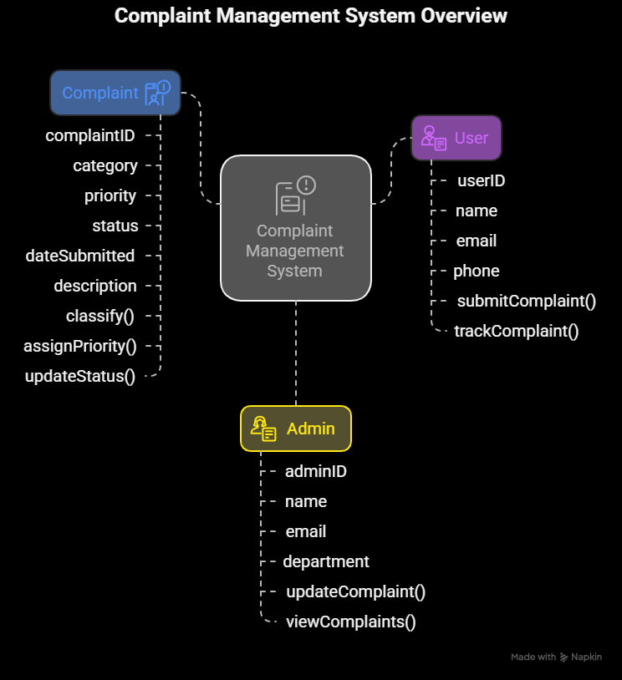

## **Entity Relationship Model (ERD)**

The ERD defines the data entities and their relationships.

**Entities:**

* **User**
* **Admin**
* **Complaint**
* **Notification**

**Relationships:**

* A **User** can lodge multiple **Complaints**.
* An **Admin** can manage multiple **Complaints**.
* Each **Complaint** generates multiple **Notifications**.

## **Description of Technology Used**

### **Software Products**

* **Frontend:** React.js / Vue.js, HTML, CSS, JavaScript
* **Backend:** Flask (Python) / Django
* **AI/NLP:** Python libraries (NLTK, SpaCy, BERT model via Hugging Face)
* **Database:** Firebase (NoSQL) / SQLite (for local setup)
* **Notification Service:** Twilio (SMS) / SendGrid (Emails)
* **Version Control:** Git & GitHub
* **Deployment:** Firebase Hosting / Heroku

### **Hardware Requirements**

* Personal Computer / Laptop
* Minimum 4 GB RAM (8 GB Recommended)
* Stable Internet Connection
* Smartphones (for receiving SMS notifications and testing responsiveness)
* **Findings / Results of Analysis**

The AI-Based Grievance Lodging and Tracking System developed in this project effectively demonstrated how **Artificial Intelligence (AI)** and **Natural Language Processing (NLP)** techniques can be successfully integrated into a grievance redressal framework to improve operational efficiency, transparency, and public service responsiveness. Through systematic analysis, design, and implementation of the proposed system, several significant outcomes were observed.

### **Principal Outcomes:**

* **Successful Implementation of AI-Based Complaint Classification:** The NLP model built using Python libraries (SpaCy and NLTK) accurately classified incoming complaints into predefined categories like water supply, road maintenance, public safety, and health issues. The system achieved reliable classification accuracy for a mini-project scale, validating the feasibility of integrating AI-powered classification in public grievance systems.
* **Effective Priority Assignment Based on Complaint Context:** By incorporating sentiment analysis and keyword detection, the system was able to assign appropriate priority levels (High, Medium, Low) to grievances, ensuring urgent complaints received faster attention. This eliminated the limitations of manual, subjective prioritization and promoted objective, AI-driven urgency assessment.
* **Real-Time Grievance Tracking Module:** The project successfully developed a real-time tracking feature where users could monitor their complaint’s progress using a unique Complaint ID. The system displayed status updates such as Received, In Progress, Resolved and sent automated notifications via integrated APIs, improving user satisfaction and service transparency.
* **Fraud and Duplicate Complaint Detection:** An essential result was the inclusion of a rule-based system to detect duplicate and irrelevant complaints based on text similarity and content filters. This reduced administrative workload and ensured resources were directed toward genuine grievances.
* **Role-Based Access Control (RBAC) for Data Security:** The implementation of RBAC effectively restricted access to sensitive complaint data, ensuring that only authorized department officials could view, manage, and resolve grievances. This addressed potential privacy and security issues in public systems.
* **Administrative Dashboard with AI-Powered Analytics:** The developed administrator dashboard provided visual representations of complaint trends, category-wise counts, resolution rates, and priority distributions. This outcome demonstrated the usefulness of AI-driven analytics in decision-making and operational monitoring for authorities.
* **Cost-Effective, Scalable, and Cloud-Deployable Solution:** The system was successfully hosted on a cloud platform (Firebase/Heroku) with minimal resource consumption, confirming that even small organizations and local governments could implement AI-based grievance systems without significant infrastructure investments.
* **Validated Feasibility for Future Enhancements:** The project revealed strong feasibility for future upgrades such as multilingual complaint support, mobile application development, chatbot integration, and IoT-based grievance reporting — confirming the system’s adaptability for real-world smart governance applications.

**Summary of Findings:**

The project outcomes indicate that integrating AI and NLP models into grievance redressal systems **significantly improves classification accuracy, complaint prioritization, and real-time tracking capability**. Additionally, the system enhances operational efficiency, transparency, and citizen trust while offering a cost-effective, scalable, and future-ready digital governance tool.

**Cost of the Project**

### **Breakdown of Project Costs**

|  |  |  |  |
| --- | --- | --- | --- |
| **Sl. No.** | **Item/Service** | **Cost (INR)** | **Remarks** |
| 1 | **Python, Flask, Django, React.js, Vue.js** | ₹0 | Open-source software |
| 2 | **Firebase (Database & Hosting)** | ₹0 | Free tier for testing |
| 3 | **Twilio API (SMS Notifications)** | ₹0 (within free trial) | Limited to trial SMS credits |
| 4 | **SendGrid (Email Notifications)** | ₹0 | Free plan available |
| 5 | **GitHub (Version Control & Hosting)** | ₹0 | Free for students |
| 6 | **Internet Charges (Shared resources)** | ₹300 | Data consumed during testing, hosting, updates |
| 7 | **Cloud Deployment (Heroku / Firebase Hosting)** | ₹0 | Free plan usage |
| 8 | **Documentation & Report Preparation (Print/Stationery)** | ₹200 | Printing, binding, report submission |
| 9 | **Learning Materials / Online Courses (optional)** | ₹0 | Free online resources & tutorials |
| **Total Estimated Cost** |  | **₹500** | Approximate incidental expenses |

### **Cost Summary**

The total project expenditure was approximately **₹500**, covering only incidental charges such as internet usage during development, documentation, and report submission. No costs were incurred for software licenses, development tools, or cloud hosting, as the project made effective use of **open-source software and free-tier services available to students.**

### **Conclusion on Project Cost**

This project validates that **small to medium-scale AI-based grievance redressal systems can be developed at minimal cost** using open-source tools and cloud services. Such systems are financially viable for deployment in educational institutions, government organizations, and private companies with limited budgets, making advanced digital grievance management accessible and scalable without heavy infrastructure investments.

**Conclusions:**

The AI-Based Grievance Lodging and Tracking System developed as part of this mini-project successfully demonstrates the practical application of Artificial Intelligence (AI) and Natural Language Processing (NLP) in automating public grievance redressal systems. Through the systematic application of modern software development practices and AI-driven functionalities, the project has fulfilled its primary objective of simplifying, streamlining, and improving the efficiency of grievance management processes.

The project revealed that existing grievance systems are predominantly manual or limited to basic web portals, leading to frequent delays, misclassification of complaints, lack of transparency, and an absence of objective prioritization. By integrating AI models for complaint classification, sentiment-based priority assignment, real-time tracking dashboards, and automated notifications, this system provides a significant improvement over conventional approaches. Additionally, the inclusion of fraud and duplicate detection mechanisms enhances the reliability and operational efficiency of the grievance redressal process.

From a development perspective, the project benefited from an Agile methodology, allowing the team to iteratively build, test, and refine system modules in a phased manner. Open-source tools like Python, Flask/Django, React/Vue.js, Firebase, and Twilio/SendGrid APIs enabled a cost-effective and scalable solution, making this project a financially viable option for small institutions, local government bodies, and service-oriented organizations.

Another significant outcome of this project is the development of an AI-powered analytics dashboard, equipping administrators with valuable data insights about complaint trends, department-wise issue distribution, resolution rates, and frequently reported problems. This functionality supports data-driven decision-making and proactive service management, an essential aspect of modern public administration and institutional governance.

The findings from this project also indicate strong feasibility for future enhancements, including multilingual support, AI-based chatbots for grievance submission, mobile application interfaces, and IoT integration for proactive issue reporting in smart city environments.

In summary, this AI-Based Grievance Lodging and Tracking System effectively addresses the limitations of existing grievance handling methods by introducing automation, transparency, AI-driven classification, priority-based escalation, and real-time tracking — ultimately improving public service delivery, operational efficiency, and citizen satisfaction.

The successful implementation of this system in a student-driven mini-project setting also highlights the accessibility and adaptability of AI technologies for socially impactful applications, opening avenues for future research, academic innovation, and institutional adoption.

* **Project Limitations and Future Enhancements**

### **Project Limitations**

While the AI-Based Grievance Lodging and Tracking System successfully achieves its primary objectives — automating grievance lodging, classification, prioritization, and real-time status tracking — several limitations exist due to project scope, time constraints, and resource availability:

* **Limited Dataset for AI Training:** Due to the absence of access to extensive, real-world public grievance datasets, the AI/NLP model was trained on a relatively small, manually curated dataset, limiting its classification accuracy and adaptability for more complex or region-specific grievances.
* **Absence of Multilingual Support:** The current system handles grievances submitted only in English. Regional language processing was not implemented owing to time limitations and the complexity involved in training multilingual NLP models.
* **No Mobile Application Integration:** The system is web-based only, lacking a dedicated mobile application for Android or iOS platforms. This limits accessibility for users without regular access to computers.
* **Basic Rule-Based Fraud Detection:** The duplicate complaint detection mechanism operates using simple keyword-based rules rather than advanced text similarity models, reducing its effectiveness in identifying paraphrased or reworded duplicate complaints.
* **Limited AI Chatbot Functionality:** Although considered, an AI-powered chatbot for automated grievance submission and query resolution was not developed due to the project’s time and technology learning curve limitations.
* **Minimal Performance Testing at Large Scale:** Due to infrastructure and resource constraints, the system has not been tested under high-traffic scenarios or large-scale simultaneous complaint submissions.

**Future Enhancements**

Recognizing the opportunities for expanding the system’s capabilities, several enhancements can be integrated into future iterations of this project to improve functionality, user experience, and operational effectiveness:

* **Integration of Multilingual NLP Models:** Implementing AI models capable of handling complaints in multiple regional languages will improve accessibility for diverse user groups, particularly in multilingual countries like India.
* **Mobile Application Development:** Creating dedicated Android and iOS mobile apps will extend system usability and convenience, allowing citizens to lodge and track complaints on the go.
* **Advanced Fraud Detection Mechanisms:** Future versions can incorporate AI-based text similarity algorithms like cosine similarity, BERT embeddings, or fuzzy matching to detect paraphrased duplicate complaints more accurately.
* **AI-Powered Chatbot Integration:** Adding an AI chatbot for interactive grievance lodging, FAQs, and real-time issue resolution will enhance user engagement and reduce manual support workload.
* **IoT Integration for Smart City Complaints:** Integrating IoT sensors for proactive issue detection (like automatic alerts for streetlight failures, water leakage, or air quality issues) could make the system part of smart city infrastructure.
* **Department-Wise Performance Analytics:** Enhanced analytics dashboards can be developed to track department-wise complaint volumes, resolution rates, and average handling times for better governance insights.
* **Machine Learning Model Optimization:** Training AI models on larger, real-world datasets and refining NLP pipelines will improve classification accuracy, sentiment analysis, and priority prediction.
* **Cloud Scalability and Load Balancing:** Deploying the system on scalable cloud infrastructure with load balancing will support high user volumes and large-scale institutional or government deployments.

**In conclusion**, while this project delivers a practical, AI-powered grievance redressal solution within its current scope, numerous enhancements can significantly broaden its impact, usability, and operational capabilities in future implementations.

* **References:**

• Press Information Bureau, “Artificial Intelligence in Governance: Integrating AI for Efficient Grievance Redressal Systems,” Govt. of India, New Delhi, India, July 2021. [Online]. Available: <https://pib.gov.in/PressReleasePage.aspx?PRID=1735885>

• A. Pandey, “AI-Powered Complaint Management System for Enterprises,” LeewayHertz, San Francisco, CA, USA, Mar. 2023. [Online]. Available: <https://www.leewayhertz.com/ai-in-complaint-management/>

• Sprinklr Inc., “Customer Complaint Management Software Overview,” Sprinklr, New York, NY, USA, Jan. 2023. [Online]. Available: <https://www.sprinklr.com/products/customer-service/complaint-management/>

• S. Deshpande, A. Reddy, and R. Kumar, “Automated Grievance Management System using AI: A Study on Institutional Applications,” Foundry Journal, Bengaluru, India, Vol. 12, no. 3, pp. 18–25, Mar. 2024. [Online]. Available: <https://foundryjournal.net/wp-content/uploads/2024/03/2.FJ23C286.pdf>

• Consumer Financial Protection Bureau, “Consumer Complaint Database,” CFPB, Washington, D.C., USA, Jan. 2023. [Online]. Available: https://www.consumerfinance.gov/data-research/consumer-complaints/

• OpenAI, “OpenAI API Documentation,” OpenAI Inc., San Francisco, CA, USA, Jan. 2024. [Online]. Available: <https://platform.openai.com/docs>

* **Appendices**

The candidate may furnish the appendices such as specimen questionnaire / Schedule etc., under this section.

* **Publication**: Status (Published/ Accepted/Submitted) with Title, Conference Name, Organized by.